Instructions for authors of the Proceedings ARTICLE

Hlaváčová Zuzana¹ – Other Author(s)²

¹Department of Physics, Slovak University of Agriculture in Nitra
Tr. A. Hlinku 2, 949 76 Nitra, Slovakia
zuzana.hlavacova@uniag.sk

²Other affiliation(s)
Address, Postal Code, City, Country
E-mail

GENERAL INSTRUCTIONS
- Manuscript should be clearly and grammatically written in English (British);
- Page settings: A4 format, Calibri, 11 pt, single (before: 0 pt, after: 0 pt), margins 2.5 cm;
- Page numbers: do not number your manuscript;
- Article should not be longer than 6 standard pages (A4), including tables and figures;
- Article to the Proceedings of the ICYS 2019 should be send to: ana.petrovic@uniag.sk
Please note that the article to the Acta Technologica Agriculturae will be published independently and according to standard reviewing process (more information available here https://content.sciendo.com/view/journals/ata/ata-overview.xml).

Abstract (single, before: 12 pt, after: 6 pt)
Abstracts (in English) should not exceed 150 words. The Abstract should be self-contained presenting all items of the paper’s subject about which new results have been gained and emphasising the conclusions most important from scientific point of view. The Abstract should contain brief statement of: background and aims (stating the main purposes and research question), methods, results (stating the main findings) and/or conclusions.
Keywords
A set of keywords should be comprehensive, but concise, typically 4-6 words or phrases. Initial letters of keywords are written in lower-case and should be different from the words mentioned in the title.

Introduction
Introduction should provide wider context, substantiation of the need of writing and publishing the paper, its goal. It should afford a review of related works and information concerning the state of research of relevant issues. Related references are recommended. References in text should be in alphabetical order (reference example: Hlaváčová et al., 2018; Gomez and Ozen, 2016).

Material and methods
Please, provide a concise description of research material and used scientific methods. This section should consist an information of equipment, methods, experiments conducted and conditions. When methods are not original, give reference to the paper where this method was originally published. Statistical processing methods, including the software used, should also be listed.
Equations should be numbered. Equations must be written in the equation editor. Only SI units should be used.
$$η=η_{0}e^{\frac{E_{A}}{RT}}$$ | (1)
where: η - dynamic viscosity (Pa.s); $η_{0}$ - reference value of dynamic viscosity (Pa.s); E_{A} - activation energy (J.mol⁻¹); R - gas constant (J.K.mol⁻¹); T - absolute temperature (K).
Description of the table should be above the table and description of the figure is below the figure.
Tab. 1 Examples of calorific value for some motor fuels (Energie Portal, 2017)
Fuel | Calorific value  (kJ.kg⁻¹)
Gasoline | 47 300
Diesel | 44 800
Methanol | 22 884
Ethanol | 29 847
Propanol | 33 600
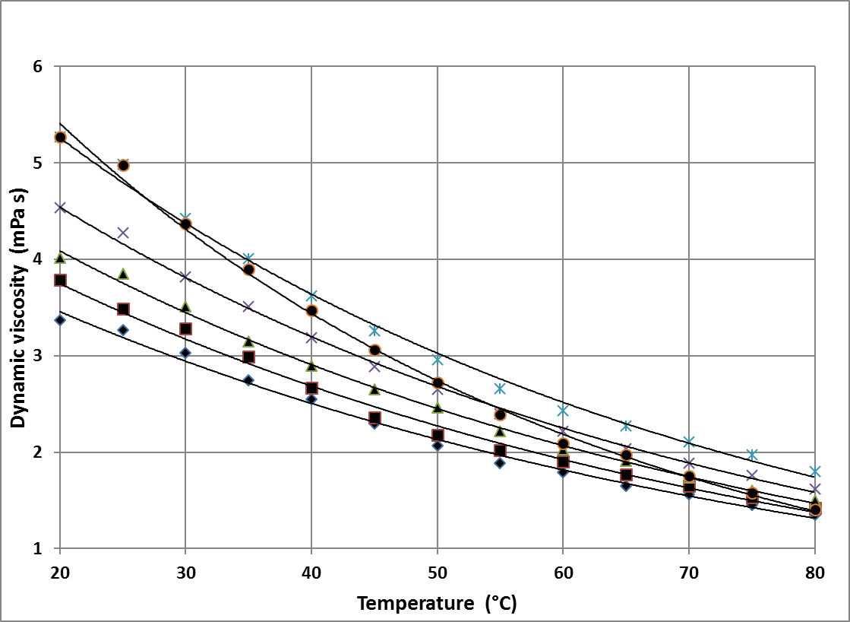
Fig. 1 Temperature dependencies of dynamic viscosity for samples of diesel with different RME content (RME content 0 % -♦, 3 % - ■, 7 % - ▲, 10 % - x, 15 % - x, 20 % - ●); (Hlaváčová, 2018)

Results and discussion

Results section should contain evaluation and exact description of achieved results. Results should be presented briefly in tables or figures. The author should confront partial results with data published by other authors. Provide enough data to give reasons for conclusions. In discussion, there is necessary to emphasise the importance of findings and to compare the information obtained with existing knowledge, if possible.
- The decimal marker is a point (0.5 m), while the thousand's separator is a comma (5,000).
- To express a unit of measurement, insert a thin space between the number and the unit (5 g; 20 ha).
- Use kg.m⁻³ instead of kg/m³.

conclusions

The main conclusions of the study may be presented in a short Conclusions section. It is necessary to mention briefly the most important results presented in the paper, the key points of following research and experimental work, and recommendations for use in practice.

acknowledgements
This work was co-funded by …

References (in alphabetical order)
Examples of references:
Journal article:
KARANDUŠOVSKÁ, I. – MIHINA, Š. – BOĎO, Š. 2012. Effect of differently designed systems of housing for dairy cows on ammonia and carbon dioxide concentration. In Acta Technologica Agriculturae, vol. 15, no. 4, pp. 106–109.
HLAVÁČOVÁ, Z. – BOŽIKOVÁ, M. – HLAVÁČ, P. – REGRUT, T. – ARDONOVÁ, V. 2018. Selected physical properties of various diesel blends. In International Agrophysics, vol. 32, no. 1, pp. 93-100.
Book:
SOANE, B. D. – VAN OUWERKERK, C. 1994. Soil Compaction in Crop Production. Amsterdam, London: Elsevier Science B. V., 684 pp. ISBN 9780080934006.
Book chapter:
GUPTA, S. C. – RAPER, R. L. 1994. Chapter 4. Prediction of soil compaction under vehicles. In SOANE, B. D. – VAN OUWERKERK, C. Soil Compaction in Crop Production. Amsterdam, London: Elsevier Science B. V., pp. 71–90. ISBN 9780080934006.
Articles published in collections and proceedings:
HRUBÝ, D. – BAJLA, J. – OLEJÁR, M. – CVIKLOVIČ, V. – TÓTH, L. 2013. New generation portable vertical penetrometer design. In Trends in Agricultural Engineering 2013. Prague: Czech University of Life Sciences Prague, pp. 223–227. ISBN 8021323884.
Legislative documents, acts:
Slovak Republic. Act no. 124/2006 on Occupational Safety and Health. Technical standard: ISO 7144: 1986. Documentation – Presentation of theses and similar documents.
Please note that all non-English document titles must be translated into English with the original title stated afterwards in brackets (). Do not use foreign-language characters (eg. Cyrillic) for eample:
KHVOSTOV, V. A. – POZOV, N. V. 1987. Dynamics of self-propelled three-axle machine unit for tilled crops. In Traktory i Selkhozmashiny, no. 4, pp. 24–28. (In Russian: Dynamika samokhodnogo trjokhosnovo agregata dlja propashnykh kultur).

